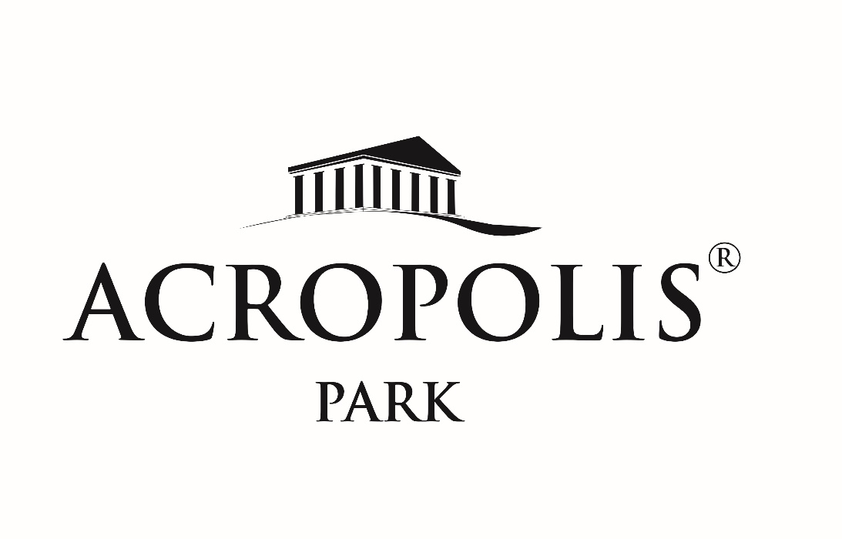

**About Us:**

Our Acropolis is a recreational destination located in the heart of Nigeria’s capital city, and a re-enactment of the Greek architectural masterpiece offering a variety of services for individuals, families and communities. We were founded on a vision to provide convenience, through a one-stop-shop facility, that offers wide-ranging services for all of your recreational and event needs.

Our environment is a serene and picturesque oasis made up of lush greenery, meticulously landscaped gardens, and vibrant floral display envisioned to mimic the Hanging Gardens of Babylon. These rich landscape is surrounds a historically strong Classical-style Architecture, which radiates a peaceful and scenic escape from the hustle and bustle of life.

As a family-friendly facility, our amenities are evolving daily for everyone to enjoy and they include playgrounds, picnic areas, recreational spaces, restaurants, shopping areas, finger food outlets, event venues, gym amongst others.

We remain committed to providing a safe and clean environment for our customers and we are staffed with well-trained personnel who ensure the safety and security of all visitors. We also maintain a high hygiene standard so everyone can enjoy our spaces.

We are conveniently and easily accessible from various parts of the City and host a variety of events all year round that brings people from various backgrounds together and promote social interaction and cohesion.

Experience the calmness and natural beauty of our facility, where you can unwind, re-energize, connect with nature, and create lasting memories with your loved ones.

**Evolution:**

Construction on our Acropolis began in 2015 and has been steady ever since. The ultimate Vision driving our Infrastructure is vast and has led to sub-dividing the Development into phases. Good things take time and we like to say “The Acropolis was not built in a day”.

The most critical phase, which set the tone for more to come, was the construction of the Retaining Walls which measured approximately 2km in length. This set the pace for a serene and multi-level recreational space. The Walls were designed to follow the existing topography which allowed us preserve the natural terrain and ecology of the environment.

Several other structures had come up ever since, paving the way for a once-in-a-lifetime landmark.

***\*\*\*insert pictures of Acropolis over the years, where we started and where we are going\*\****

Top of Form

**Founding Philosophies of Our Acropolis (The 9 Pillars):**

**\*\*\*insert picture of the 9 pillars\*\*\***

**Peace:** We are dedicated to providing an escape from the busy and fast-paced schedules of our clients, where everyone can find a peaceful and tranquil experience. This is evident from the moment you arrived, when you will be enveloped with the sound and calm of nature into which our services and integrated. We believe peace should be an experience and not just an idea or concept.

**Love:** Our team is dedicated to providing an exceptional experience to our clients, centered on the power of Love and making sure everyone feels valued and cherished. Our personalized approach ensures that everyone receives the attention and support they need because we understand that Love is an vital human need and not just an emotion.

**Excellence:** We are dedicated to exceeding expetations by our level of detail and care with the aim of setting a standard for excellence. Our meticulously planned landscape and customer servic aims to create an environment where excellence thrives because we believe excellence should be a lifestlye and not just a goal.

**Perseverance:** We take pride in our commitment to continous improvement because we understand its importance in achieving growth and overcoming challenges. Our infrastructure is built on the foundation of resilience, converting what was somewhat an unusable landscape into a renowned facility which continues to evolve every day. Our intention is to nuture resilience by creating an environemnt that radiates inner strength and motivation to our clients.

**Satisfaction:** Our priority is to ensure all of our customers are satisfied and we do this by taking the time to listen every need befre providing personalized solutions to them, because we understand every customer is different.

**Joy:** Our environemnt and services are dedicated to fostering happpiness and this is embedded into every detail of our facility, We believeJoy is a fundamental emotion that enhaces the overall well-being of people which is why we ensure our services are delivered with the utimate goal of bringing joy and happiness.

**Unity:** Our services and infrastructure are cohesive into one entity. We believe this is vital in delivering exceptional service to our customers. In as uch as we provide an array of services, our team work in harmony to ensure the needs of our customers are met with professionalism ad efficiency. Our high standards are possible through the collective efforts of our team.

**Strength:** This a one of our core pillars and is evident in our physical infrastructure through the use of the Doric Order which is often characterised by strength, durability, a sense of solidity and reliability. Our facility is designed to be a pillar of strength for our clients by providing a safe and reliable environment where they are confident of getting steadfast devotion.

**Honor:** We pride ourselves in the highest form of Integrity and so we are committed to upholding the principles of honor in every of our interactions be it financial or physical. We do this by being transparent and open in all of our communication because we believe a trusthworthy trait opens a lot of doors.

**The Acropolis:**

The word “Acropolis” comes from the Greek words ἄκρον (akron) which means "highest point, extremity" and πόλις (polis) which means "city". Acropolis literally means “Highest city” in Greek. The most notable Acropolis is locate in Athens, Greece and is considered one of the most important cultural and architectural landmarks in the world.

The Construction of this Acropolis dates back to 1600-1100 BC but it was during the 5th Century BC, the Golden Age that it reached its peak of Glory; it served as a symbol of Athens’ power, wealth and cultural achievements. The Acropolis has undergone various modifications over the years especially during the Roman, Byzantine, and Ottoman periods, when it was converted into a Christian site and later a mosque. However, many of the original structures on the Acropolis have survived to this day.

The Acropolis, along with its monuments, has been designated as a UNESCO World Heritage Site since 1987, remains a significant symbol of ancient Greek civilization and attracts about 3 million visitors yearly.

**Our Services:**

**Acropolis Grills**

**Acropolis Shopping**

**Acropolis Foods**

* **Indoor restaurant**
* **Outdoor restaurant**

**Acropolis Pastries**

**Acropolis Space Rental**

* **Indoor Space**
* **Outdoor spaces**

**Acropolis Gym**

**Acropolis Banking**

**Acropolis Games**

**Acropolis Lodge**

**Acropolis e-connect**

**Acropolis Cultural corner**

**Acropolis Green:** Part of our vision is for our facility to serve as an educational site, a venue to enlighten the society about the benefits of a serene floral space in the fight against deforestation and climate change.

**Our Brands**

Other than our architecture, we pride ourselves in items unique to us, that you can take away and will remind you of your visit. Some of these are:

**Acropolis Spice**

**Acropolis Pastries**

**Acropolis Souvenirs**